Supplementary material
Table S1: Primers used for this study
SNP_ID | 2nd - PCRP | 1st - PCRP | UEP DIR | UEP SEQ
rs231362 | ACGTTGGATGATGGGTTGCCTAGAGACAAG | ACGTTGGATGGTAGCTCACCTGCCTTTGAC | R | TTCCCTCGCCCGTCA
rs2237895 | ACGTTGGATGCTCCTATGACTTCGATTCCC | ACGTTGGATGAGATGACAGGGCAGTGACAG | R | ACCTGTCCCCGACCCC
rs231356 | ACGTTGGATGCCCATTCTTCAAGGGAAACG | ACGTTGGATGGTACAGCAATTTCAGAACCC | R | ggggAACGGTCCCCTTAAGAA
rs2283228 | ACGTTGGATGACATGTGTTTACCCATCACG | ACGTTGGATGCTGCTGGAAGGTTTGGTGAC | R | cctgTTACCCATCACGTTTAACCAG
rs163184 | ACGTTGGATGAGGTGGTAAAGTGTCTGTGG | ACGTTGGATGTTTGCTCAGTAACGGACTGG | R | CCTCTCTCTTTACTCCAA
rs163177 | ACGTTGGATGTGCTCCACAGGCCAACTCT | ACGTTGGATGATGTCAAAGGCAAGCGCACT | F | gggCTTTCAAGGGTTAACGG
rs117601636 | ACGTTGGATGAAAAGTTGCTGGGAAGGCTG | ACGTTGGATGCAGTGGCTGAACTAATTTG | R | gagagAAGGGAACGCTTATACACTG
rs8181588 | ACGTTGGATGTACAGAGACCTTTCCAGAGC | ACGTTGGATGGTTCATTGACTGTTCTGGGC | R | ccctgCCAGAGCTCAAGGACT
PCR polymerase chain reaction, UEP unextended mini-sequencing primer.

Table S2 Haplotype frequencies of KCNQ1 gene and the association with diabetes risk
Hierarchical category | Block | SNPs | Haplotype | Freq | Before adjusted |  | After adjusted
 |  |  |  |  | OR (95% CI) | p‐value | OR (95% CI) | p‐value
Age > 59 | Block 1 | rs231362|rs231356 | AA | 0.878 | 1.15(0.80-1.64) | 0.456 | 1.18(0.82-1.72) | 0.376
 |  |  | GA | 0.901 | 1.11(0.76-1.63) | 0.600 | 1.08(0.73-1.60) | 0.711
 |  |  | GT | 0.775 | 1.15(0.87-1.51) | 0.339 | 1.15(0.86-1.53) | 0.357
 | Block 2 | rs163184|rs2283228 | TC | 0.700 | 1.35(1.05-1.75) | 0.021* | 1.33(1.02-1.74) | 0.035*
 |  |  | GA | 0.492 | 1.19(0.93-1.52) | 0.169 | 1.15(0.89-1.47) | 0.294
 |  |  | TA | 0.80 | 0.85(0.62-1.15) | 0.289 | 0.82(0.59-1.13) | 0.217
Female | Block 1 | rs231362|rs231356 | AA | 0.872 | 0.83(0.55-1.25) | 0.368 | 0.83(0.55-1.26) | 0.376
 |  |  | GA | 0.098 | 0.86(0.56-1.32) | 0.498 | 0.86(0.56-1.32) | 0.503
 |  |  | GT | 0.77 | 0.97(0.71-1.33) | 0.856 | 0.97(0.71-1.33) | 0.861
 | Block 2 | rs163177|rs163184 | CG | 0.480 | 1.28(0.98-1.67) | 0.070 | 1.28(0.98-1.68) | 0.067
 |  |  | CT | 0.965 | 0.70(0.32-1.55) | 0.378 | 0.70(0.32-1.54) | 0.375
 |  |  | TT | 0.476 | 0.74(0.57-0.97) | 0.030* | 0.74(0.56-0.97) | 0.027*
Non-smokers | Block 1 | rs231362|rs231356 | AA | 0.161 | 1.4(0.93-2.11) | 0.106 | 1.73(1.06-2.81) | 0.027*
 |  |  | GA | 0.928 | 1.46(0.89-2.38) | 0.132 | 1.37(0.80-2.33) | 0.250
 |  |  | GT | 0.763 | 0.93(0.67-1.28) | 0.645 | 0.82(0.56-1.18) | 0.277
 | Block 2 | rs163177|rs163184 | CG | 0.472 | 1.03(0.78-1.36) | 0.843 | 1.04(0.77-1.40) | 0.807
 |  |  | TG | 0.987 | 0.61(0.15-2.48) | 0.493 | 0.54(0.10-2.81) | 0.465
 |  |  | CT | 0.976 | 0.90(0.35-2.28) | 0.817 | 0.94(0.35-2.51) | 0.901
 |  |  | TT | 0.491 | 0.94(0.71-1.25) | 0.675 | 0.93(0.68-1.27) | 0.658
Drinkers | Block 1 | rs231362|rs231356 | AA | 0.912 | 1.86(0.93-3.71) | 0.080 | 2.33(1.02-5.33) | 0.045*
 |  |  | GA | 0.904 | 1.18(0.60-2.32) | 0.624 | 1.38(0.56-3.42) | 0.487
 |  |  | GT | 0.809 | 1.56(0.93-2.61) | 0.091 | 2.19(1.12-4.27) | 0.022*
 | Block 2 | rs163177|rs163184 | CG | 0.508 | 1.31(0.82-2.07) | 0.257 | 1.26(0.72-2.21) | 0.424
 |  |  | TG | 0.97 | 0.62(0.15-2.56) | 0.506 | 1.05(0.17-6.66) | 0.960
 |  |  | TT | 0.455 | 0.72(0.45-1.14) | 0.165 | 0.76(0.44-1.33) | 0.342
Non-drinkers | Block 1 | rs231362|rs231356 | AA | 0.163 | 1.48(0.99-2.2) | 0.057 | 1.93(1.20-3.11) | 0.007*
 |  |  | GA | 0.924 | 1.22(0.75-1.99) | 0.415 | 1.15(0.68-1.94) | 0.598
 |  |  | GT | 0.755 | 0.81(0.59-1.12) | 0.199 | 0.70(0.48-1.00) | 0.050
 | Block 2 | rs163177|rs163184 | CG | 0.475 | 1.06(0.81-1.39) | 0.683 | 1.08(0.81-1.45) | 0.603
 |  |  | TG | 0.989 | 0.76(0.19-3.09) | 0.704 | 0.70(0.14-3.61) | 0.672
 |  |  | CT | 0.966 | 0.88(0.41-1.9) | 0.745 | 1.02(0.45-2.33) | 0.964
 |  |  | TT | 0.48 | 0.92(0.7-1.21) | 0.543 | 0.91(0.68-1.23) | 0.549
BMI < 24 | Block 1 | rs231362|rs231356 | AA | 0.15 | 1.66(1.01-2.72) | 0.044 | 1.59(0.91-2.77) | 0.100
 |  |  | GA | 0.915 | 1.34(0.77-2.32) | 0.306 | 1.12(0.60-2.09) | 0.727
 |  |  | GT | 0.762 | 0.85(0.58-1.23) | 0.383 | 0.78(0.50-1.20) | 0.254
 | Block 2 | rs163177|rs163184 | CG | 0.531 | 1.40(1.01-1.93) | 0.044* | 1.45(1.00-2.08) | 0.049*
 |  |  | CT | 0.962 | 0.91(0.38-2.18) | 0.835 | 1.06(0.39-2.90) | 0.911
 |  |  | TT | 0.423 | 0.70(0.50-0.98) | 0.036* | 0.68(0.46-0.99) | 0.044*
OR odds ratio, 95% CI 95% confidence interval;
p values were calculated with Pearson′s χ 2 tests;
* indicates statistical significance (p < 0.05).

Table S3 Main characteristics of studies included in the meta-analysis for rs2237895
Study | Ethnicity | Year | region | Case | Control | No. of case/ control | Genotyping method | Mean age of case/ control | Gender of case/control (% male) | Control |  |  | Case
 |  |  |  |  |  |  |  |  |  | AA | CC | CA | AA | CC | CA
Liu et al. | Chinese ( Shanghai, China) | 2009 | East Asian | T2D per WHO criteria | Normal fasting glucose | 1,912/2,041 | TaqMan | 53.9/58.1 | 41.0/31.1 | 790 | 886 | 209 | 942 | 883 | 169
Chen et al. | Chinese | 2010 | East Asian | T2D patient | Normal fasting glucose | 57/341 | TaqMan | NA/52.3 | NA/48.2 | 23 | 26 | 8 | 162 | 138 | 41
Hu et al. | Chinese ( Shanghai, China) | 2009 | East Asian | T2D per WHO criteria | Normal glucose tolerence | 1,769/1,734 | MassARRAY | 61.1/57.3 | 52.1/41.4 | 770 | 699 | 173 | 636 | 759 | 234
Unoki et al. | Japanese | 2008 | East Asian | T2D per WHO criteria | Normoglycemic | 3,557/1,352 | Affymetrix GeneChip SNP arrays. | 61.5/45.5 | 60.0/60.0 | 1225 | 7633 | 577 | 567 | 580 | 152
Unoki et al. | Japanese | 2008 | East Asian | T2D per WHO criteria | Normoglycemic | 1367/1266 | Affymetrix GeneChip SNP arrays. | 61.1/71.6 | 59.4/38.9 | 1070 | 1830 | 736 | 1577 | 2201 | 712
Unoki et al. | Singaporean | 2008 | East Asian | T2D per WHO criteria | Normoglycemic | 1498/1881 | Affymetrix GeneChip SNP arrays. | 63.9/35.4 | 49.1/44.0 | 574 | 709 | 214 | 801 | 848 | 232
Unoki et al. | Dane | 2008 | East Asian | T2D per WHO criteria | Normoglycemic |  | Affymetrix GeneChip SNP arrays. | 60.0/46.9 | 59.3/46.3 | 1082 | 1854 | 750 | 1578 | 2203 | 714
Yasuda et al. | Japanese | 2008 | East Asian | T2D patient | Non-diabetic participants | 4378/4412 | GeneChip, PCR-based Invader assay | 61.9/58.5 | 55.7/46.1 | 1546 | 2087 | 692 | 1939 | 1926 | 487
Yasuda et al. | Chinese | 2008 | East Asian | T2D patient | Non-diabetic participants | 1416/1577 | GeneChip, PCR-based Invader assay | 50.0/25.1 | 40.4/46.1 | 506 | 698 | 212 | 684 | 697 | 194
Yasuda et al. | Korean | 2008 | East Asian | T2D patient | Non-diabetic participants | 758/632 | GeneChip, PCR-based Invader assay | 59.2/64.7 | 46.7/45.4 | 334 | 366 | 52 | 237 | 291 | 100
Saif-Ali et al. | Chinese ( Malaysian) | 2011 | East Asian | T2D patient | Non-diabetic participants | 300/230 | RFLP | 49.8/52.9 | 51.0/61.3 | 123 | 147 | 30 | 120 | 96 | 14
Saif-Ali et al. | Chinese ( Malaysian) | 2011 | East Asian | T2D patient | Non-diabetic participants | 300/230 | RFLP | 49.8/52.9 | 51.0/61.3 | 123 | 147 | 30 | 111 | 96 | 11
Yu et al. | Chinese ( Shanghai) | 2012 | East Asian | T2D per WHO criteria | Normal glucose tolerance | 3259/3,408 | MassARRAY | 60 /50 | 48.0/41.0 | 971 | 1207 | 384 | 1039 | 1391 | 465
Yu et al. | Chinese ( Hong Kong) | 2012 | East Asian | T2D per WHO criteria | Normal glucose tolerance | 5,962/644 | MassARRAY | 57/41 | NA/NA | 551 | 578 | 146 | 663 | 832 | 282
Cui et al. | Chinese (Kazakh population) | 2016 | East Asian | T2D per WHO criteria | Non-diabetic participants | 100/100 | RFLP | 51.21/49.85 | 55/46 | 40 | 49 | 11 | 32 | 51 | 17
Zhang et al. | Chinese ( born in PUMCH) | 2015 | East Asian | T2D per WHO criteria | Non-diabetic participants | 547/634 | TaqMan | 60.9/57.4 | 288/289 | 239 | 241 | 65 | 325 | 257 | 52
Wang et al. | China (Wuhan, Hubei) | 2013 | East Asian | T2D per WHO criteria | Non-diabetic participants | 1920/1920 | TaqMan | 53.23/56.84 | 58.6/58.6 | 790 | 874 | 256 | 924 | 812 | 184
Wang et al. | China (Wuhan, Hubei) | 2013 | East Asian | T2D per WHO criteria | Non-diabetic participants | 613/723 | TaqMan | 53.34/54.08 | 63.0/46.5 | 248 | 316 | 49 | 346 | 321 | 56
YD et ai. | Chinese ( Jiangsu province) | 2013 | East Asian | T2D per WHO criteria | Non-diabetic participants | 2925/3281 | RFLP | 58.22/56.58 | 37.54/37.61 | 1233 | 1289 | 374 | 1546 | 1390 | 322
Been et al. | Northern states of India | 2011 | South Asian | T2D per WHO criteria | Normoglycemic | 1,428/1,593 | TaqMan | NA/NA | NA/NA | 410 | 610 | 265 | 359 | 473 | 188
Been et al. | US Asian Indian participants | 2011 | South Asian | T2D per WHO criteria | Normoglycemic | 1848/1,617 | TaqMan | NA/NA | NA/NA | 40 | 67 | 32 | 206 | 249 | 96
Saif-Ali et al. | Malaysian | 2011 | South Asian | T2D patient | Non-diabetic participants | 234/177 | RFLP | 48.5/44.9 | 45.3/45.8 | 123 | 107 | 91 | 62 | 20 | 8
van et al. | Dutch | 2012 | Caucasian | World Health Organization, 2006 | Non-diabetic participants | 336/510 | TaqMan assay | 51.50/48.75 | 54.38/56.01 | 1522 | 2158 | 869 | 1803 | 2516 | 863
Riobello et al. | Spanish Renastur cohort (Caucasians) | 2016 | Caucasian | T2D per WHO criteria | Healthy participants | 4620/5285 | TaqMan | 64.3/51.1 | 43.3/41.9 | 65 | 90 | 25 | 155 | 251 | 95
Turki et ai. | Tunisian Arabs | 2012 | Other | T2D per WHO criteria | Non-diabetic participants | 180/501 | TaqMan | NA/NA | NA/NA | 350 | 429 | 107 | 233 | 261 | 80
Al-Shammari et al. | Saudi Arabian population | 2017 | West Asian | T2D per WHO criteria | Non-diabetic participants | 900/600 | PCR-RFLP | 61.2/52.0 | 37.8/45.5 | 122 | 150 | 58 | 202 | 223 | 91
NA: not available;
PCR-RFLP: polymerase chain reaction-restriction fragment length polymorphism.

Table S4 Main characteristics of studies included in the meta-analysis for rs2283228
Study | Year | Ethnicity | region | Case | Control | No. of case/ control | Genotyping method | Mean age of case/ control | Gender of case/control (% male) | Control |  |  | Case
 |  |  |  |  |  |  |  |  |  | AA | CC | CA | AA | CC | CA
Chen et al. | 2010 | Chinese | East Asian | T2D patient | Normal fasting glucose | 57/341 | TaqMan | NA/52.3 | NA/48.2 | 28 | 100 | 90 | 23 | 91 | 66
Unoki et al. | 2008 | Japanese | East Asian | T2D per WHO criteria | Normoglycemic | 194/1558 | GeneChip | 54.6 /55.2 | 64.4/36.0 | 134 | 436 | 266 | 24 | 84 | 80
Unoki et al. | 2008 | Japanese | East Asian | T2D per WHO criteria | Normoglycemic | 1367/1113 | GeneChip | 63.5/59.7 | 61.7/53.5 | 178 | 547 | 370 | 167 | 638 | 557
Unoki et al. | 2008 | Japanese | East Asian | T2D per WHO criteria | Normoglycemic | 1630/1078 | GeneChip | 61.5/45.5 | 60.0/39.8 | 217 | 590 | 426 | 449 | 1592 | 1379
Unoki et al. | 2008 | Japanese | East Asian | T2D per WHO criteria | Normoglycemic | 886/706 | GeneChip | 61.1/71.6 | 59.4/38.9 | 217 | 590 | 426 | 449 | 1592 | 1379
Unoki et al. | 2008 | Singaporean | East Asian | T2D per WHO criteria | Normoglycemic | 1498/1881 | Affymetrix GeneChip SNP arrays. | 63.9/35.4 | 49.1/44.0 | 243 | 812 | 692 | 194 | 667 | 612
Unoki et al. | 2008 | Dane | East Asian | T2D per WHO criteria | Normoglycemic |  | Affymetrix GeneChip SNP arrays. | 60.0/46.9 | 59.3/46.3 | 29 | 706 | 4154 | 15 | 469 | 3413
Saif-Ali et al. | 2011 | Chinese | East Asian | T2D patient | Non-diabetic participants | 300/230 | RFLP | 49.8/52.9 | 51.0/61.3 | 33 | 33 | 99 | 27 | 105 | 168
Saif-Ali et al. | 2011 | Chinese ( Malaysian) | East Asian | T2D patient | Non-diabetic participants | 300/230 | RFLP | 49.8/52.9 | 51.0/61.3 | 33 | 89 | 99 | 27 | 105 | 168
Wang et al. | 2013 | China (Wuhan, Hubei) | East Asian | T2D per WHO criteria Association criteria (American Diabetes Association, 2008) | Non-diabetic participants | 1920/1920 | TaqMan | 53.23/56.84 | 58.6/58.6 | 244 | 920 | 756 | 174 | 851 | 895
Wang et al. | 2013 | China (Wuhan, Hubei) | East Asian | T2D per WHO criteria Association criteria (American Diabetes Association, 2008) | Non-diabetic participants | 613/723 | TaqMan | 53.34/54.08 | 63.0/46.5 | 92 | 326 | 305 | 66 | 242 | 305
Saif-Ali et al. | 2011 | Malaysian | South Asian | T2D patient | Non-diabetic participants | 234/177 | RFLP | 48.5/44.9 | 45.3/45.8 | 21 | 83 | 73 | 21 | 72 | 141
Imran Ali Khan et ai. | 2015 | Indian | South Asian | T2D per WHO criteria | Normoglycemic | 250/250 | PCR-RFLP | 57.19/53.93 | 55.2/57.6 | 2 | 17 | 231 | 4 | 41 | 205
Turki et ai. | 2012 | Tunisian Arabs | North Africa | T2D per WHO criteria | Non-diabetic participants | 900/600 | restriction fragment length polymorphism (PCR-RFLP) analysis, | 61.2/52.0 | 37.8/45.5 | 3 | 53 | 519 | 2 | 77 | 812
NA: not available;
PCR-RFLP: polymerase chain reaction-restriction fragment length polymorphism.

Figure legends.
Figure S1. The linkage disequilibrium (LD) block constructed by rs231362, rs231356, rs163184 and rs2283228 in KCNQ1 gene at the Age of > 59.
Figure S2. The linkage disequilibrium (LD) block constructed by rs231362, rs231356, rs163177 and rs163184 of KCNQ1 gene in female.
Figure S3. The linkage disequilibrium (LD) block constructed by rs231362, rs231356, rs163177 and rs163184 of KCNQ1 gene in non-smoking patients.
Figure S4. The linkage disequilibrium (LD) block constructed by rs231362, rs231356, rs163177 and rs163184 in the KCNQ1 gene of patients drinking alcohol.
Figure S5. The linkage disequilibrium (LD) block constructed by rs231362, rs231356, rs163177 and rs163184 of KCNQ1 gene in patients who do not drink alcohol.
Figure S6. The linkage disequilibrium (LD) block constructed by rs231362, rs231356, rs163177 and rs163184 in KCNQ1 gene when BMI < 24.
Figure S7. Forest plot of rs2237895 polymorphism and the risk of T2DM under the dominant model (aa/ca vs cc).
Figure S8. Forest plot of rs2237895 polymorphism and the risk of T2DM under the recessive model (aa vs cc/ca).
Figure S9. Forest plot of rs2237895 polymorphism and the risk of T2DM under the homozygote comparison (aa vs cc).
Figure S10. Forest plot of rs2237895 polymorphism and the risk of T2DM under the heterozygote comparison (ca vs cc).
Figure S11.Forest plot of rs2283228 polymorphism and the risk of T2DM under the dominant model (aa/ca vs cc).
Figure S12. Forest plot of rs2283228 polymorphism and the risk of T2DM under the recessive model (aa vs cc/ca).
Figure S13. Forest plot of rs2283228 polymorphism and the risk of T2DM under the homozygote comparison (aa vs cc).
Figure S14. Forest plot of rs2283228 polymorphism and the risk of T2DM under the heterozygote comparison (ca vs cc).
Figure S15. Assess publication bias for the association of rs2237895 polymorphism with the risk of T2DM.
Notes: (A) Assess publication bias for the association of rs2237895 polymorphism with the risk of T2DM in allele model. (B) Assess publication bias for the association of rs2237895 polymorphism with the risk of T2DM in dominant model. (C) Assess publication bias for the association of rs2237895 polymorphism with the risk of T2DM in recessive model. (D) Assess publication bias for the association of rs2237895 polymorphism with the risk of T2DM in homozygote comparison. (E) Assess publication bias for the association of rs2237895 polymorphism with the risk of T2DM in heterozygote comparison.
Figure S16. Sensitivity analysis for the association of rs2237895 polymorphism with the risk of T2DM.
Notes: (A) sensitivity analysis for rs2237895 polymorphism and the risk of cancer under the allele model. (B) sensitivity analysis for rs2237895 polymorphism and the risk of cancer under the dominant model. (C) sensitivity analysis for rs2237895 polymorphism and the risk of cancer under the recessive model. (D) sensitivity analysis for rs2237895 polymorphism and the risk of cancer under the homozygote comparison. (E) sensitivity analysis for rs2237895 polymorphism and the risk of cancer under the heterozygote comparison.
Figure S17. Assess publication bias for the association of rs2283228 polymorphism with the risk of T2DM.
Notes: (A) Assess publication bias for the association of rs2283228 polymorphism with the risk of T2DM in allele model. (B) Assess publication bias for the association of rs2283228 polymorphism with the risk of T2DM in dominant model. (C) Assess publication bias for the association of rs2283228 polymorphism with the risk of T2DM in recessive model. (D) Assess publication bias for the association of rs2283228 polymorphism with the risk of T2DM in homozygote comparison. (E) Assess publication bias for the association of rs2283228 polymorphism with the risk of T2DM in heterozygote comparison.
Figure S18. The sensitivity analysis for the association of rs2283228 polymorphism with the risk of T2DM.
Notes: (A) sensitivity analysis for rs2283228 polymorphism and the risk of T2DM under the allele model. (B) sensitivity analysis for rs2283228 polymorphism and the risk of T2DM under dominant model. (C) sensitivity analysis for rs2283228 polymorphism and the risk of T2DM under recessive model. (D) sensitivity analysis for rs2283228 polymorphism and the risk of T2DM under homozygote comparison. (E) sensitivity analysis for rs2283228 polymorphism and the risk of T2DM under heterozygote comparison.

Figure S1

Figure S2

Figure S3
Figure S4
Figure S5

Figure S6

Figure S7
Figure S8
Figure S9
Figure S10
Figure S11
Figure S12
Figure S13
Figure S14
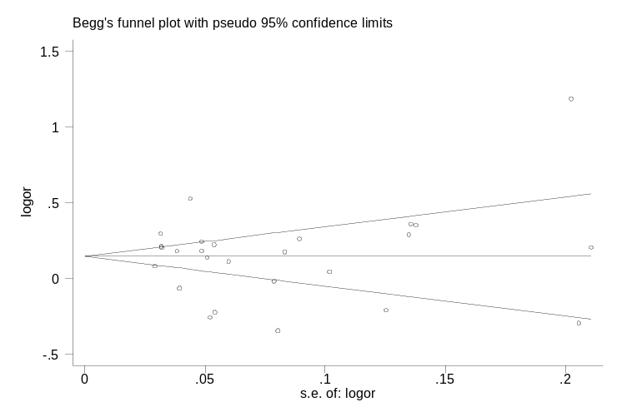
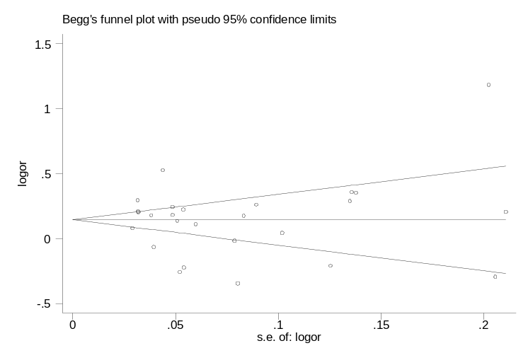
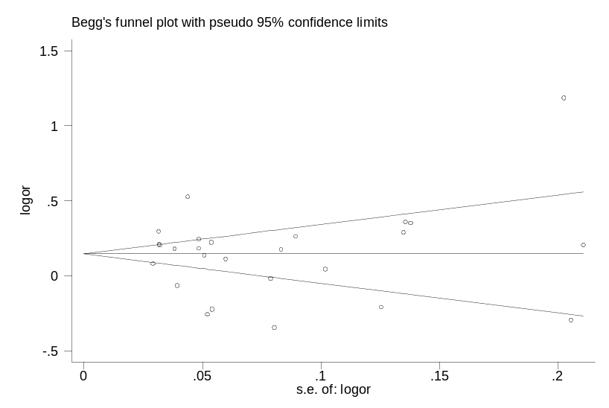
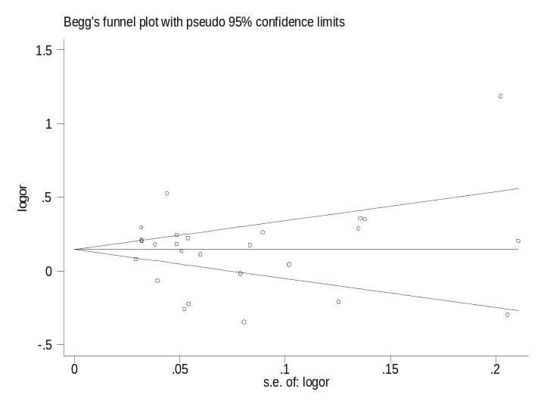
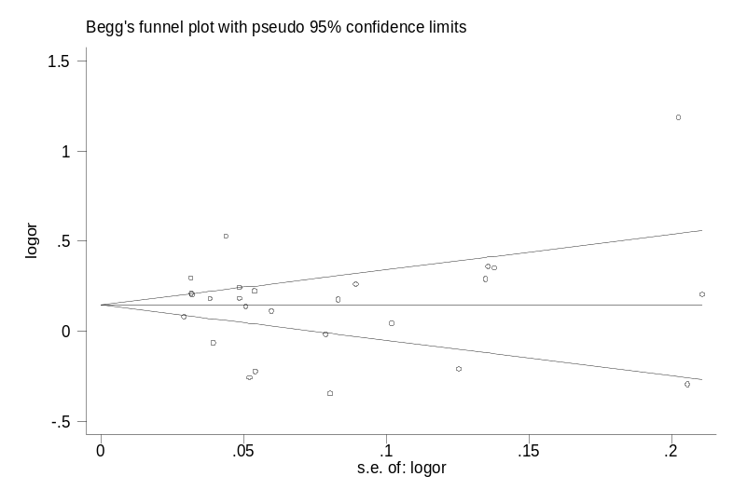
A
B
C
D
Figure S15
E
E
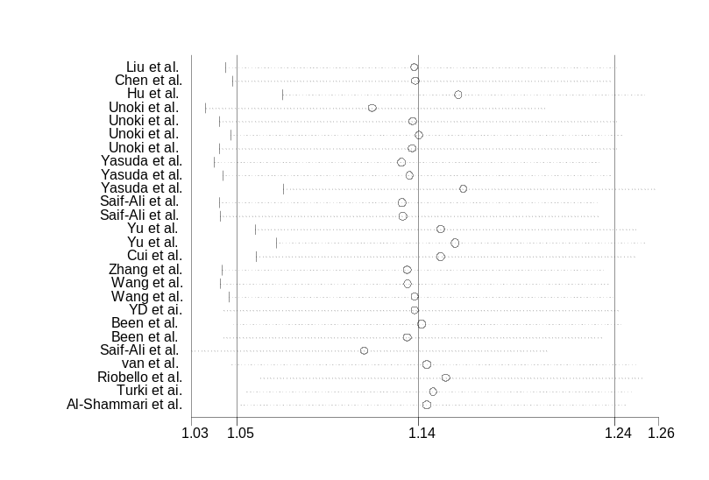
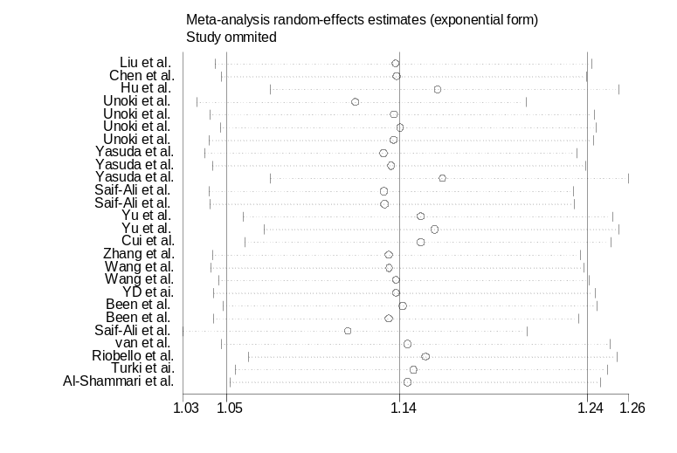
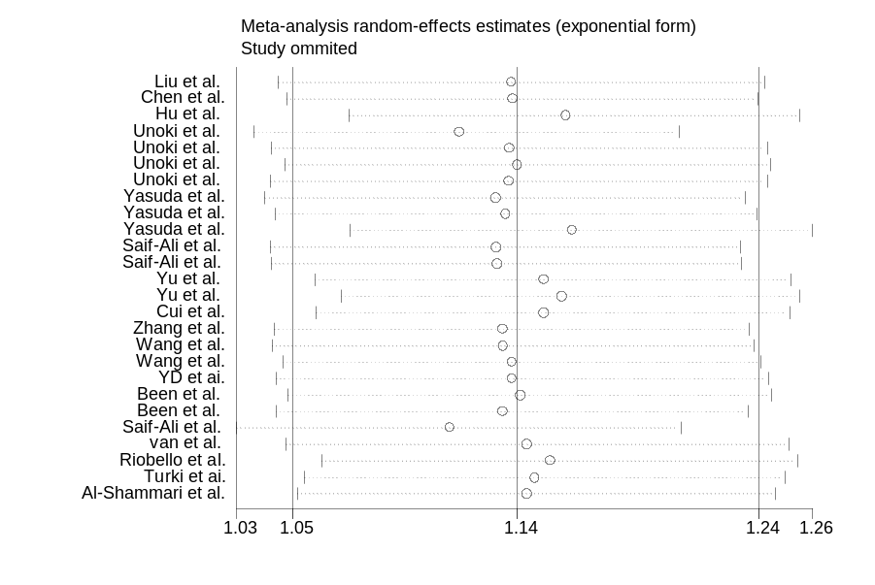
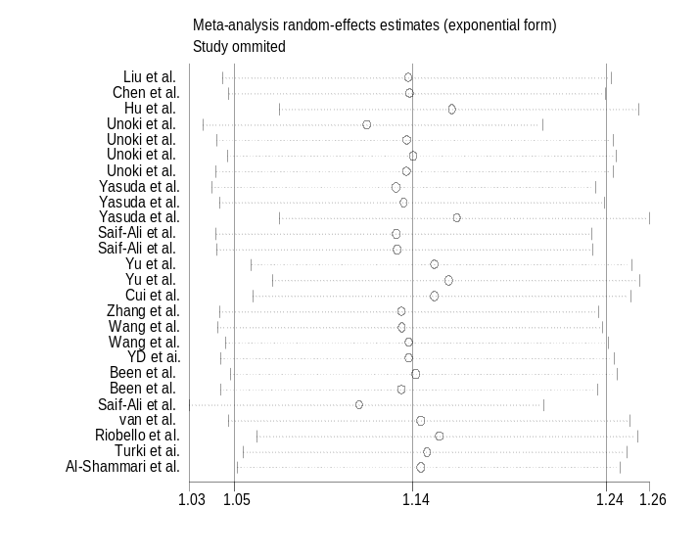
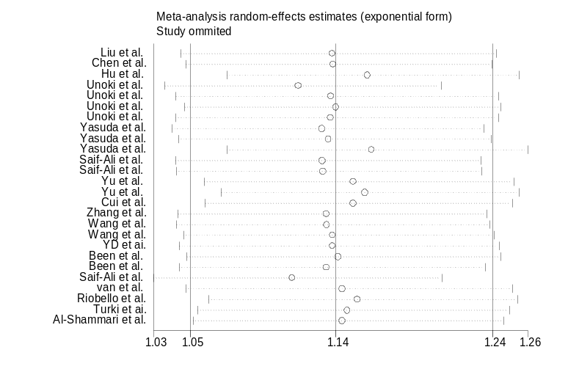
Figure S16
A
B
C
D
E

C
E
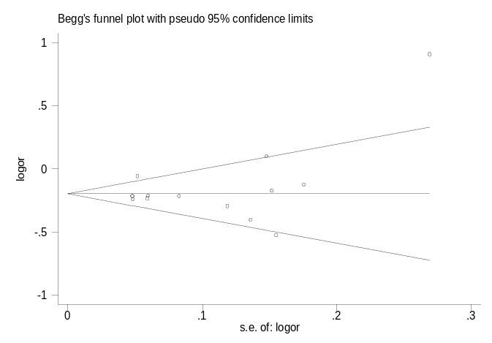
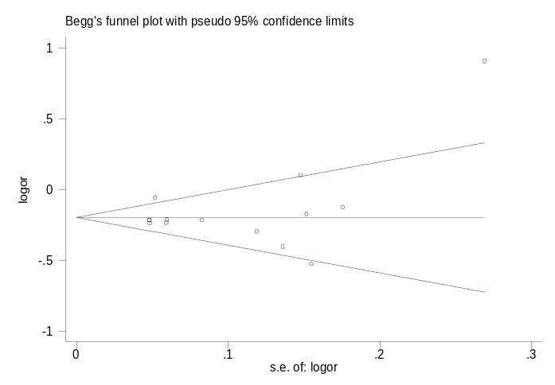
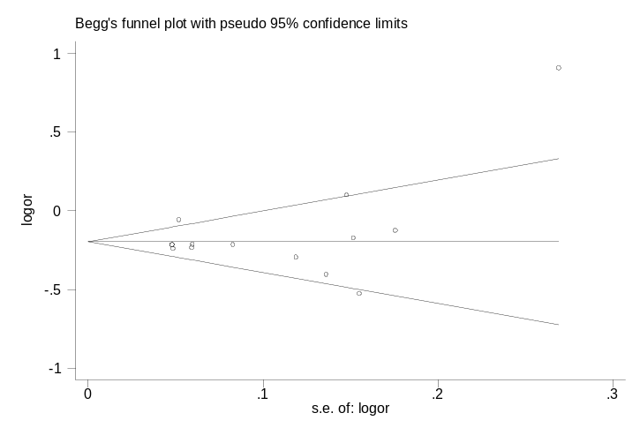
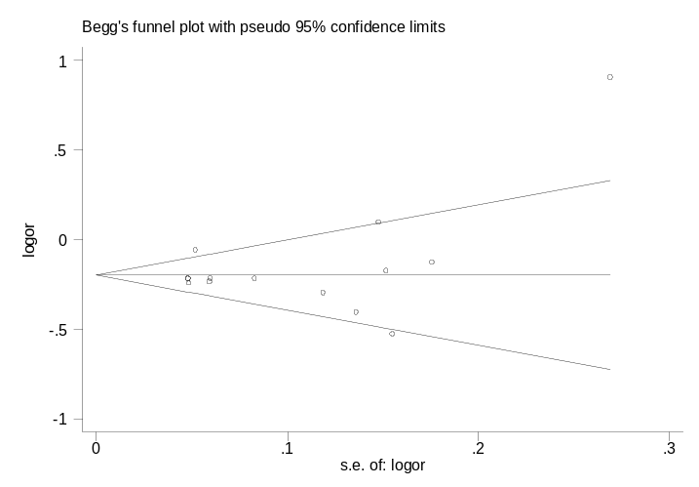
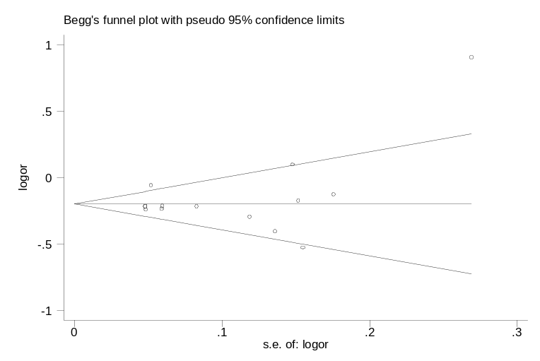
B
C
A
D
E
Figure S17
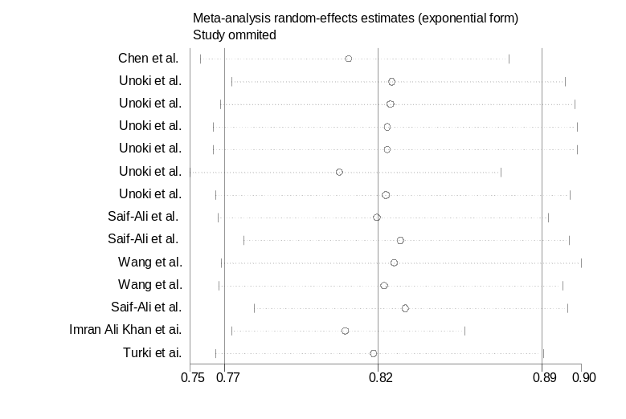
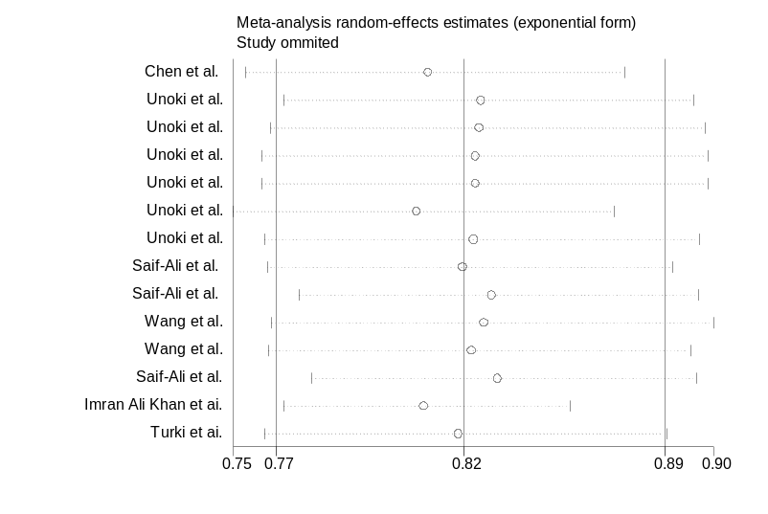
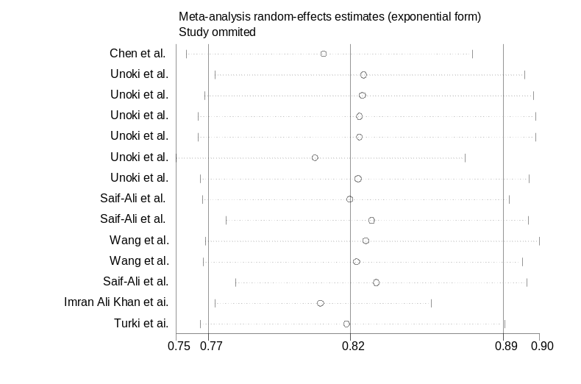
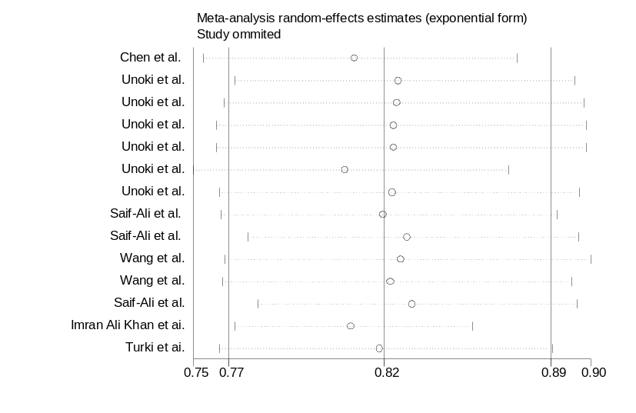
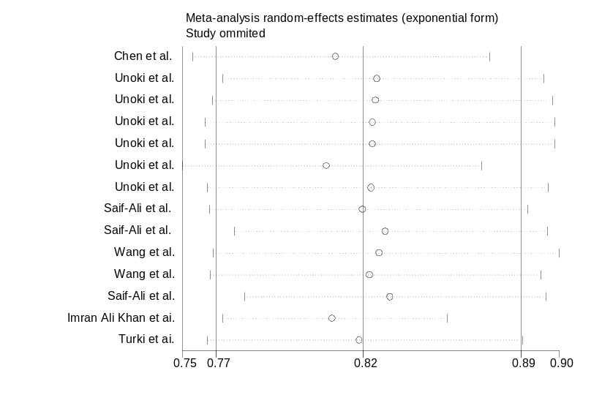
Figure S18
A
B
E
D
C

